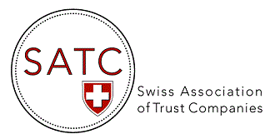

AGENDA 2023

Events & Webinars

DATE | TOPIC
21 March 2023 | Trust Accounting & Editing Seminar organized & held in conjunction with STEP, Four Seasons Hotel de Bergues, Geneva
3-4 May 2023 | Presence at the STEP Alpine Conference, Interlaken (as exhibitor)
25 April 2023 | Webinar : Retrocessions – an overview by Liti-Link team (Zoom)
23 May 2023 | Webinar : Cross-border tools & services for trustees by BRP Bizzozero & Partners (Zoom)
6 June 2023 | 16th AGM of SATC, Fairmont Grand Hotel Geneva
28 & 29 June 2023 | Roundtable on Cross-border planning series 2023 – Macfarlanes  (Geneva & Zürich) – registration with Macfarlanes
November 2023 | 16th EGM of SATC, by video conference (ZOOM)

