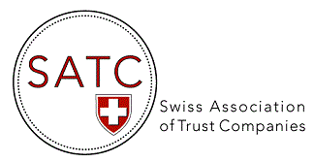

AGENDA 2022

Events & Webinars

DATE | TOPIC
4-5 May 2022 | Presence at the STEP Alpine Conference, Interlaken (as exhibitor)
17 May 2022 | 15th AGM of SATC, Zunfthaus zur Zimmerleuten, Zurich
31 August 2022 | Webinar on Cyber Security and Cyber Resilience (ZOOM)  With the collaboration of the NCSC and the Swiss FS-CSC
27 September 2022 | Webinar on Digital Solutions for the secure storage/sharing of documents (ZOOM) (Presentation of "My Swiss Keeper”)
29 September 2022 | Trust Accounting & Editing Seminar organized & held in conjunction with STEP (in Zurich)
6 October 2022 | Webinar - The UK Trust Register and Register of Overseas Entities: top tips for any trust with a UK connection (ZOOM) With the collaboration of Macfarlanes LLP
15 November 2022 | 15th EGM of SATC – by video conference (ZOOM)

